The Alpha Bounce Shoe
Name:
Professor:
Course title:
Institution:
Date:
The Adidas has used cutting edge technology to come its latest line up of running shoes. The new Alpha bounce shoe shaped using ARAMIS, a motion-capture system which helps to investigate the forces of tension and strain due to various materials (Boyd, and Rajasekharan, 2018, p.151).The technique uses high-speed cameras with flexion sensors to gather information at up to 500 frames per second. The software has the ability to screen through the body, bones and different muscles detecting various points of strain. This makes it easy for the Adidas engineers to design shoes that suit the needs of the user. This inspired the design of the Alpha bounce shoe which is durable, comfortable and affordable.
There is more tech quotient to the shoe which has dictated the entire shoe make over (Dickson, 2011, p.115). The upper part of the shoe is made using Forged Mesh and consequently the upper layer is made of a seamless piece. This has differentiated the shoe within the market. The shoe stands out due to its softness and smooth texture.
Not only is the shoe light in weight but also flexible and comfy. Moreover, it is lined with a mesh that makes it both strong and securely fit. This aspect makes the shoe durable. Additionally, the shoe is designed to offer maximum comfort from its cushioning. Although it is not like a fluffy shoal but it is kept firm to serve its purpose as a trainer. Specifically, it offers a spring effect absorbing excess force exerted during exercise. The new shoes have taken comfort aspect to the next level. Taking into consideration the need to protect the calf muscles, the shoe absorbs the jarring impact and muzzles the noise and irritant sound from the ground as runner sprints .The shoe has circular trends and the outsole is exclusively designed to minimize friction and offer firm grip of the ground when running. The following is a bill of the materials that have been used to create the heavenly feel.

BILL OF MATERIALS
PRODUCT NAME | Alpha bounce Shoes | ITEM  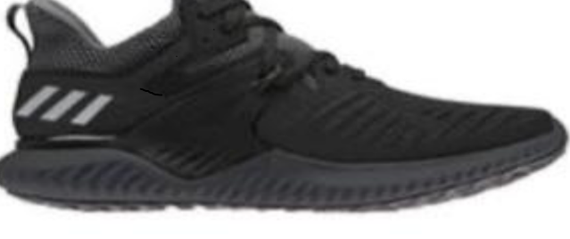
COMPANY | ADIDAS
RETAIL PRICE | $100
PART NUMBER | PART NAME | DESCRIPTION | QUANTITY
1 | Outsole | Continental rubber from heel to toe for extraordinary traction in wet and dry conditions. | 1
2 | Midsole | Made of elastic foam engineered to feel soft and bouncy. | 1
3 | Heel Counter | Fit counter molded heel counter which provides a natural fit that allows optimal movement of the Achilles. | 1
4 | Upper | This is the top part of the shoe. It is made with flexible light weight material: Forged Mesh. It is fixed with one layer of material for comfort and unrestricted movement. Also it has a costate pattern for support and size flexibility | 1
5 | Inner sole | 4mm thick made of algae-based EVA foam | 1
6 | Rope lace | Multicolored | 1
 |  | TOTAL PARTS | 7

Alpha bounce
Assembly
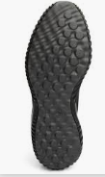
2. Midsole

- Outer sole
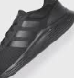
4. Upper
3. Heel counter

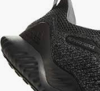
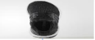
5. Innersole
6. Rope lace
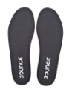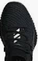

By the time the exclusive Alpha bounce gets to the leg it has undergone various processes. These include transformation of raw materials to various parts and then the final assembling. The Adidas footwear production involves manufacturing industries for raw materials such as rubber, cotton and polyester, processing industries to transform these into partial finished products where forming, cutting, designs and technology apply and assembling industries that put together different parts to form the final products. The last stage is labelling after which the products are taken to the distribution centers worldwide (Kozak, 2018, p.32).
Most of the production done by Adidas is outsourced. Adidas works with about 700 independent factories from around the world that manufacture various products in more than 50. The supply chain is global and multi-layered, with many different types of business partners, some of whom are directly contracted factories, while others are not. The top five countries per region by number of supplier sites are Asia which includes China, Vietnam, Korea, Indonesia and India, America particularly United States, Brazil, Argentina, Canada, and El Salvador and the EMEA which comprises of Germany, Turkey, Italy, United Kingdom, and Spain (Inside Adidas' supply chain. (2019, November 13)) .The table below shoes the raw materials used and their sources:
 | Material | Source | Exact Location | Price
A | Rubber | Thailand, Brazil, Vietnam | Brazil: Avenida Antonio Braga de Azevedo, 407  Thailand: 110 Moo 13, Mitraphab Rd Bantrad, | $8
B | Foam | China | No.888 of AnHua Road | $15
C | Boost | German | Gottlieb-Daimler-Straße 8 | $15
D | Polyurethane | Taiwan | No. 413 Section 2, Ching Yun Road | $7

The following is the supply chain for the new alpha bounce shoes with both the upstream and downstream tiers:
Upstream Downstream
2nd Tier 1st Tier
ARAMIS tech and Bounce manufacturer
Midsole processing
Alpha bounce manufacturer and ARAMIS tech

1st Tier 2nd Tier 3rd Tier
Outsole processing
Rubber manufacturer
Consumers
Rebel Sports
Distribution centers

3
Innersole processing
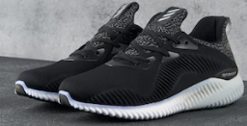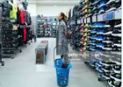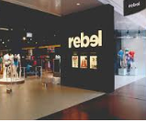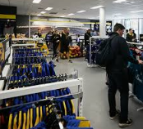
Eva foam manufacturer
As per the above diagram, the three different types of manufacturers (Aramis Tech and bounce, rubber and Eva foam manufacturers) supply their products to the 1st tier for processing before getting to Alpha bounce manufacturer. Later on, Alpha bounce manufacturer take the products to the first tier (distribution center) who takes sells the products to second tier (rebel Sports) and then to third tier (who are the consumers). Importance of this chain is that the big businesses are able to make a consultation with local communities and engage with international non-governmental organization. Alpha bounce manufacturers tries as much as possible to understand the source of their raw material and understand different risks that are present in multiple supply tiers of supply chain. At the same time, they struggle to know their customers. However, as the chain continues being larger, their capabilities to get the aforementioned information diminishes.

Reference
Kozak, D., 2018. The development of a sustainability strategy with a focus on environmental issues in the context of MNCs: the business case of Adidas (Doctoral dissertation). 22-54 https://repositorio.ucp.pt/handle/10400.14/25526
Inside Adidas' supply chain. (2019, November 13). Supply Chain Digital - The Procurement & Supply Chain Platform. https://www.supplychaindigital.com/supply-chain-management/inside-adidas-supply-chain
Dickson, M. J., & Fuss, F. K. (2011). Effect of acceleration on optimization of Adidas bounce shoes. Procedia Engineering, 13, 107-112. https://doi.org/10.1016/j.proeng.2011.05.059
Boyd, A.P. and Rajasekharan, A., International Business Machines Corp, 2018. Bill of material synchronization. U.S. Patent 10,140,588. https://patents.google.com/patent/US10140588B2/en

